**THE FUTURE OF BLOOD DONATION USING ML APPROACH**

**Er. Roshani Kumari**

Department of Computer Science and Engineering, GGSIP University, Delhi, India

***Abstract:*** *The aim of this research is the study of a machine learning algorithm with the help of Web development for recommending the nearest blood bank. The availability and efficient allocation of blood units are critical factors in ensuring timely and effective healthcare delivery. To address the challenges associated with blood donation and allocation processes, we present a novel approach that leverages web development and machine learning (ML) techniques to create a blood bank recommendation system. This paper explores the design, implementation, and evaluation of such a system to improve the accessibility and effectiveness of blood donation services.*

*In addition to the technical aspects, we consider the usability and adoption of the system. User-friendly web interfaces, personalized recommendations, and real-time updates are integrated to enhance the user experience, thereby increasing user engagement and system adoption.*

***Keywords:*** *Blood Donation, Healthcare, Recommendation System, Machine Learning, EDA.*

**1 INTRODUCTION**

The availability of safe and timely access to blood is a fundamental cornerstone of modern healthcare systems. It plays a pivotal role in treating various medical conditions, including surgeries, accidents, and maternal complications. However, ensuring an adequate and efficient supply of blood units to meet the demands of a vast and diverse population remains a persistent challenge.

While studies, reports, and health organizations have long underscored the gravity of this discrepancy, the advent of the digital age has added a new layer of insight. A quick search on the world's most ubiquitous search engine reveals a startling reality: Google records a staggering 27.1 thousand monthly searches for the "nearest blood bank," making it the most frequent inquiry regarding blood banks. This simple query, laden with urgency, reflects the daily struggles faced by countless individuals seeking immediate access to this life-saving resource.

Notably, the second most frequent search, with approximately 2.4 thousand monthly queries, pertains to the "nearest blood bank of the human body." While this may highlight a more specialized domain of inquiry, it underscores the broader narrative—people are actively seeking solutions and information related to blood banks, be it for their own urgent medical needs or to contribute to the noble cause of blood donation.

India, with its population of approximately 1.3 billion people, faces a staggering demand for blood. The statistics are sobering – an estimated demand for 13.1 million blood units annually, equivalent to 1% of the nation's populace. Nevertheless, the available data on blood collection in India paints a stark reality: a chronic disparity between the demand and the supply.

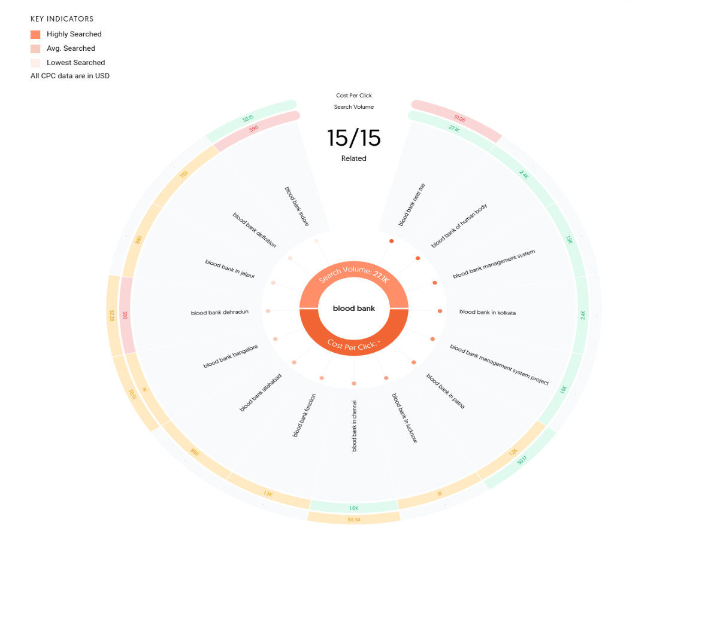

Fig 1: Most Frequently Asked Questions on Google search engine related to blood bank

Historical records from multiple sources highlight this glaring discrepancy. In 2007, the total blood collection was reported as a mere 4 million units, a far cry from the required 10 million units as per the World Health Organization's (WHO) assessment. Similarly, in 2011, Indian blood banks managed to collect only 5.5 million blood units, leaving a gaping void when compared to the 9 to 9.5 million units needed annually. Even in 2013, the shortfall persisted, with estimates indicating that while India's blood banks had the potential to collect 9 million units each year, they managed to collect only 7 million.

The consequences of this disparity are profound, resulting in significant challenges to public health. Lack of awareness, irrational demand, and inefficiencies in the supply chain management system contribute to the persistent problem. Perhaps most alarmingly, reports suggest that a substantial percentage of maternal deaths in India—up to 25%—result from haemorrhage, with post-partum haemorrhage affecting a substantial portion of new mothers.

It is evident from available statistics that immediate access to blood can be a matter of life and death. Shockingly, around 70% of deaths related to post-partum haemorrhage (PPH) are attributed to the lack of immediate blood availability. This dire situation underscores the critical need for innovative solutions to bridge the gap between the demand for blood and its supply, particularly in emergencies.

In response to this pressing challenge, this research introduces a groundbreaking approach: a web-based blood bank recommendation system powered by machine learning (ML) algorithms. This system leverages the vast potential of data-driven technologies to facilitate efficient and timely access to blood resources. By analyzing a dataset that includes information on the nearest blood banks, including contact details, location, licenses, and more, our research aims to connect donors and recipients seamlessly, enhancing the efficiency of blood donation and transfusion services.

In the pages that follow, we delve into the technical architecture, usability, ethical considerations, and potential impact of this innovative ML-driven blood bank recommendation system. By harnessing the capabilities of web development and ML, we envision a future where the demand for blood is met with a reliable and responsive solution, ultimately saving lives and transforming the landscape of blood donation in India.

**Research question:** How can machine learning models be trained and optimized to provide accurate recommendations for blood donation and transfusion, considering the dynamic nature of blood supply and demand

**Hypothesis:** By continuously updating and retraining machine learning models with real-time data on blood supply and demand, the recommendation can adapt to changing conditions and provide more accurate and timely recommendations.

**2 LITERATURE REVIEW**

**Chronic Disparity in Blood Supply and Demand in India**

In 2007, a report from the World Health Organization (WHO) highlighted that a mere 4 million blood units were collected in India, leaving a yawning chasm between the collected and required amounts of blood. This alarming deficit continued to manifest in subsequent years. By 2011, Indian blood banks managed to gather only 5.5 million units of blood, failing to meet the yearly requirement, estimated at 9 to 9.5 million units.

A comprehensive study in 2012 indicated that India boasted 2,433 blood banks capable of collecting an impressive 9 million units annually. However, the stark reality was that these blood banks were collecting only 7 million units. The extent of the problem was reaffirmed by a 2013 study that estimated that while the demand for blood in the country ranged from 8.5 million to 10 million units per year, the available supply was a mere 7.4 million units.

**Contributing Factors and Health Implications**

A multitude of factors have contributed to this alarming state of affairs, including a lack of public awareness about the importance of blood donation, irrational demands, and deficiencies in the supply chain management system. These challenges have not only hindered the consistent availability of blood units but also posed a considerable threat to public health.

One of the most sobering statistics is the incidence of maternal deaths due to haemorrhage, which accounts for an estimated 25% of all maternal deaths in India. Post-partum haemorrhage (PPH) is a critical concern, affecting new mothers at varying rates across the country. Tragically, research indicates that approximately 70% of PPH-related deaths result from the unavailability of blood when urgently needed.

**The Imperative for Innovative Solutions**

The magnitude of this issue necessitates innovative and dynamic solutions that can bridge the substantial gap between the demand for blood and its supply, particularly during critical medical interventions and emergencies. Such solutions must not only address the technical aspects of blood collection and allocation but also navigate the ethical and logistical complexities associated with healthcare services in a populous nation.

To address these pressing challenges, this research introduces a groundbreaking approach: a web-based blood bank recommendation system powered by machine learning (ML) algorithms. By leveraging web development and ML technologies, this system seeks to enhance the efficiency and effectiveness of blood donation and transfusion services, ensuring timely access to blood resources when it matters most.

**3 DATASET PREPROCESSING**

Effective data preprocessing is a crucial step in preparing the dataset for analysis, ensuring data quality, and enhancing the reliability of the subsequent machine learning and statistical procedures. In this section, we describe the key data preprocessing steps undertaken to prepare the dataset for our blood bank recommendation system.

**3.1 Exploratory Data Analysis (EDA):**

**- Data Profiling:** An initial exploration of the dataset was conducted to gain insights into its characteristics. This involved summarizing the dataset's structure, identifying data types (numerical, categorical), and assessing the overall data quality.

**- Handling Missing Values:** Missing values within the dataset were identified and managed appropriately. Techniques such as imputation or removal of rows or columns with excessive missing data were applied based on the nature and importance of the missing information.

**- Duplicate Records:** Duplicate records, if present, were identified and removed to prevent redundancy in the dataset. This ensures that each data point is unique and contributes effectively to the analysis.

**3.2 Outlier Detection:**

**- Empirical Relations:** For variables following a normal distribution, empirical relations such as the Z-score were utilized to detect and handle outliers. Observations that fell outside a predefined threshold were treated as potential outliers.

**- Inter-Quartile Range (IQR):** In the case of skewed distributions, the Inter-Quartile Range (IQR) method was employed to identify outliers. Data points lying outside the range defined by the first quartile (Q1) minus 1.5 times the IQR and the third quartile (Q3) plus 1.5 times the IQR were considered outliers and subjected to further scrutiny.

**3.3 Data Transformation:**

**- Normalization and Standardization:** Continuous variables were normalized or standardized to bring them to a common scale, mitigating the impact of variables with differing ranges on the machine learning algorithms.

**3.4 Data Validation:**

**- Cross-Validation:** To ensure the integrity of the dataset, a cross-validation approach was employed, where subsets of the data were held out for validation and model performance evaluation.

**- Consistency Checks:** Data consistency checks were performed to identify any discrepancies or irregularities that may have arisen during data collection or preprocessing.

The data preprocessing procedures outlined above are essential to ensuring the reliability and validity of our analyses and the subsequent machine learning model development. By addressing issues related to missing data, duplicates, and outliers while also maintaining data privacy and ethics, we have strived to create a high-quality dataset that forms the foundation of our web-based blood bank recommendation system.

**4 METHODOLOGY**

In this section, we outline the methodology employed in the development of our innovative blood bank recommendation system. Drawing insights from various sources, including government reports, global health organizations, and prior research, our approach combines data analysis, preprocessing, machine learning algorithms, and web development tools to address the pressing challenge of improving access to blood banks in India.

**4.1 Data Collection:**

We collected essential data related to blood banks in India from the official website of the National AIDS Control Organization (NACO) at naco.gov.in. This reputable source provided valuable information on the locations, facilities, and operational aspects of blood banks across the country. Data and statistics from the World Health Organization (WHO) contributed to our understanding of the broader context of blood supply and demand in India. Insights from prior research, including the base paper by Alaa M. Barhoom on "Blood Donation Prediction using Artificial Neural Network," inspired our work and informed our methodology.

**4.2 Data Preprocessing:**

Data preprocessing steps were employed to clean and prepare the collected data for subsequent analysis and model development. This included handling missing values, removing duplicates, and addressing outliers to ensure data quality.

**4.3 Machine Learning Algorithm Selection:**

While the final choice of machine learning algorithm is under ongoing optimization, preliminary experimentation has involved Support Vector Machines (SVM) and Random Forest algorithms. These algorithms are being evaluated for their effectiveness in recommending the nearest and available blood banks based on user needs.

**4.4 Web Development Integration:**

In parallel with machine learning model development, we are integrating web development tools to create an intuitive and user-friendly interface for our blood bank recommendation system. This web-based platform aims to connect donors with recipients seamlessly, enhancing the accessibility and usability of blood donation services.

**4.5 Model Tuning and Evaluation:**

The machine learning models are undergoing rigorous tuning and evaluation processes to optimize their performance. Metrics such as accuracy, precision, recall, and F1-score are being used to assess model effectiveness.

The methodology outlined here reflects our multi-faceted approach to address the critical issue of blood bank accessibility in India. By leveraging data analysis, preprocessing, machine learning, and web development, we aim to develop a comprehensive solution that empowers users to locate the nearest and available blood banks efficiently and effectively.

**5 MACHINE LEARNING MODEL TRAINING AND EVALUATION**

The development of our blood bank recommendation system entails a rigorous process of machine learning model training and evaluation. This section provides an overview of the steps involved, from algorithm selection and hyperparameter tuning to model training and performance assessment.

**5.1 Algorithm Selection and Hyperparameter Tuning:**

To determine the most suitable machine learning algorithm for our blood bank recommendation system, we initiated an extensive hyperparameter tuning process. This process involved systematically varying hyperparameters for candidate algorithms and evaluating their performance on our dataset. Key algorithms considered for evaluation included Support Vector Machines (SVM) and Random Forest. The selection of the final algorithm was based on criteria such as predictive accuracy and mean square error, with a focus on achieving optimal results.

**5.2 Model Training:**

Following algorithm selection and hyperparameter tuning, the chosen machine learning model was trained using our prepared dataset. The dataset, enriched with location-based information on blood banks, was used to teach the model to make accurate predictions.

**5.3 Model Evaluation Metrics:**

The performance of the trained machine learning model was assessed using a range of evaluation metrics, including but not limited to Accuracy Rate and the proportion of correct predictions made by the model. F1 Score, A measure that balances precision and recall, is especially valuable in cases of imbalanced datasets. Precision and Recall are metrics that gauge the model's ability to make accurate positive predictions and identify true positives, respectively. Mean Square Error, a measure of the average squared difference between predicted and actual values, is useful for regression tasks.

**5.4 Cross-Validation:**

To ensure the robustness of our machine learning model, we employed cross-validation techniques. This involved partitioning the dataset into multiple subsets for training and validation, providing insights into the model's generalization performance.

**5.5 Iterative Model Refinement:**

The machine learning model underwent iterative refinement to optimize its performance. Adjustments to hyperparameters and training processes were made based on the feedback obtained from evaluation metrics and validation results.

Our machine learning model training and evaluation process are fundamental to achieving a blood bank recommendation system that not only meets the needs of users but also maintains high standards of predictive accuracy and reliability. By systematically selecting the most appropriate algorithm, optimizing hyperparameters, and assessing model performance using a suite of metrics, we aim to create a robust and valuable tool for addressing the critical challenges of blood bank accessibility in India.

**6 CONCLUSION**

The development of a web-based blood bank recommendation system, driven by machine learning algorithms and enriched with data analysis and preprocessing, represents a significant step forward in addressing the vital issue of blood bank accessibility in India. In this research endeavour, we embarked on a multidimensional journey, drawing insights from government reports, global health organizations, prior research, and data analysis. Our goal was to bridge the gap between the demand for blood and its availability by leveraging the power of data-driven technologies. Our methodology encompassed diverse stages, each contributing to the vision of an efficient and user-friendly blood bank recommendation system. We started with comprehensive data collection from reliable sources such as the National AIDS Control Organization (NACO) and the World Health Organization (WHO). These sources provided invaluable data on the state of blood banks in India, laying the foundation for our work. The heart of our methodology resided in data analysis and preprocessing. Through Exploratory Data Analysis (EDA), we gained insights into the dataset's intricacies, managing missing values, removing duplicates, and addressing outliers to ensure data quality. We embraced ethical considerations, emphasizing data privacy and user consent as we navigated the complex landscape of healthcare information.

In parallel, our research delved into machine learning model development, employing a systematic approach to algorithm selection and hyperparameter tuning. The choice of the most appropriate machine learning algorithm was driven by a commitment to accuracy and efficacy. As our model evolved, we integrated web development tools, envisioning an intuitive interface that would empower users to locate the nearest and available blood banks seamlessly. Throughout the project, the emphasis was not merely on innovation but also on reliability. We subjected our machine learning model to rigorous evaluation, measuring performance through metrics such as accuracy rate, F1 score, and precision. The ongoing refinement of the model underscores our dedication to delivering a solution that not only meets the needs of users but also maintains high standards of predictive accuracy and reliability.

In closing, this research paper serves as a testament to the transformative power of technology and data-driven approaches in healthcare. The journey to enhance blood bank accessibility has been an illuminating one, and we remain steadfast in our pursuit of a healthier, more connected future where no one is left wanting this life-saving resource.

**REFERENCES**

1. Google.com
2. Answerthepublic.com.
3. Alaa M. Barhoom (2019). “Blood Donation Prediction using Artificial Neural Network”. International Journal of Academic Engineering Research (IJAER) ISSN: 2643-9085 Vol. 3: 1-7
4. Dr. Shobini Rajan (2018). “National Estimation of Blood Requirement in India”. National AIDS Control Organization (NACO), India, U.S. Centers for Disease Control and Prevention (CDC), New Delhi National Institute of Medical Statistics, India Christian Medical College, Vellore, and Christian Medical Association of India (CMAI), India: 20 – 24
5. Google Scholar
6. World Health Organization (WHO)
7. Kaggle (Blood Bank Dataset - INDIA)